View in Browser





2024 - Clean Energy Trends
As 2024 comes to a close, and with the uncertainties that lie ahead from a new federal administration, it’s a good time to take stock of the trends in clean energy in the U.S. Below you will find a snapshot of recent progress and the future outlook for key technologies that are central to our transition away from fossil fuels.
While there are legitimate concerns that this progress may slow somewhat in the next few years, the combination of falling clean energy technology costs, state mandates and consumer preferences makes it almost certain that this progress towards clean technologies will continue.
Happy Holidays!

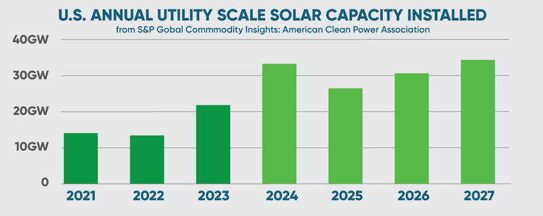

A record year for utility solar
Utility solar installations have been booming around the world and the US is heading towards a record year with over 32GW of installations in 2024, a 50% increase over 2023 installations.
Some experts anticipate a slowdown in 2025 due to threatened solar tariffs from the Trump administration, but growth is projected to continue as the costs of utility solar installations further decline.

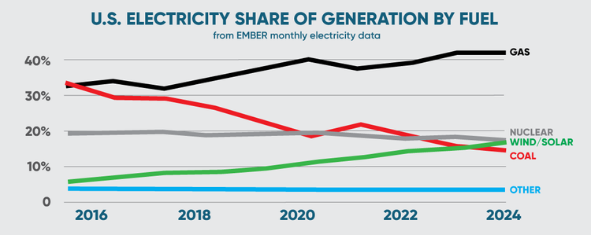

Wind and solar overtake coal
Wind and solar powered 17% of US electricity generation in 2024 - 90TWh more than last year, and enough to supply 9 million homes with clean electricity. Renewables are pushing coal generation out of the mix as coal continues decades of falling production with another 5% decline this year.
Just 20 years ago coal produced 50% of US electricity but facilities have been ramping down at a continuous pace with 5 more aging coal plants planned for closure in the coming years.
Globally, renewable energy is on course to meet nearly half of global electricity demand by the end of this decade.

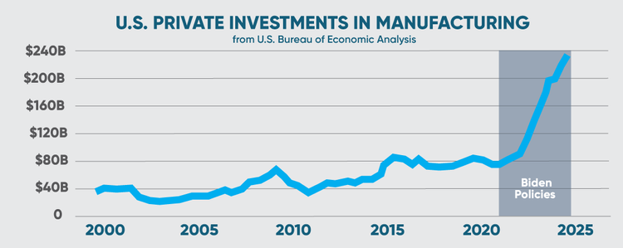

U.S. manufacturing gains momentum
Biden administration policies have resulted in historic levels of private investment in domestic manufacturing not seen since the 1950s. 2024 annual construction spending has topped $230B, a tripling of investment since 2019. Another $600B has already been pledged for future production of semiconductors, electric vehicles and batteries.
While domestic manufacturing jobs have steadily declined since peaking in 1979, the combination of tax incentives, tariffs, government contracts and a renewed focus on supply chain resilience is poised to reverse that decline.
White house policies have fueled more than $200B in clean energy manufacturing with the vast majority located in Republican led districts. This should make it harder to roll back these policies which are benefitting the entire country with an increase in high paying manufacturing jobs.

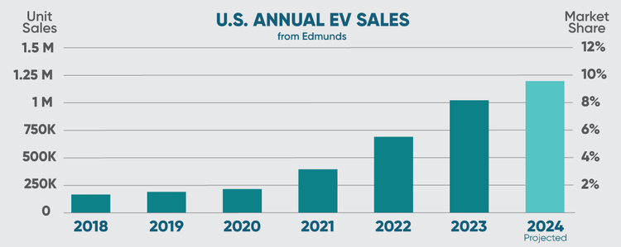

EV sales see continued rapid growth
Despite the news of a slowdown, US EV sales in November 2024 increased by nearly 14% over the same month last year and are poised for another record year in annual sales.
- Plug in vehicle sales are tracking towards 10% of total vehicle sales for the year while ICE vehicles continue their declining market share.
- 80% of battery electric vehicles sold in the US were manufactured domestically.
- EV fast charging stations have tripled in the US since 2021 with nearly 50,000 DC Fast Charge Ports now available across the country.
- Plug in vehicles are forecast to hit 40% of sales in the US by 2030, and nearly 45% globally.

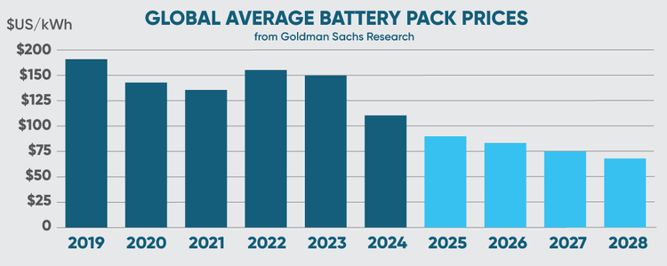

Battery prices decline steeply
Lower raw materials costs and other technological advancements are leading to rapidly declining battery costs. Prices are forecast to drop below $100 per kWh in 2025 and further decline to $80 by 2026, the price at which EVs should achieve parity with gasoline cars.
Battery production is forecast to increase 400% by 2030 with demand from EVs and energy storage systems rising dramatically. Improvements to Lithium-ion technology are expected as well as the emergence of new solid state battery technologies.

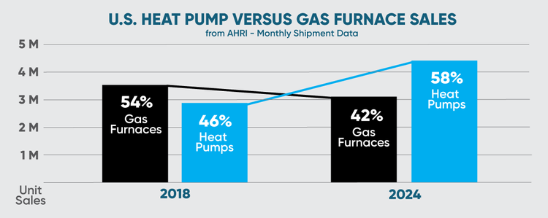

Heat pump sales outpace gas furnaces
Changing consumer preferences and improved heat pump performance coupled with federal and state incentives have supercharged heat pump sales over the last 5 years. All major suppliers of heating equipment have robust lines of heat pump products and new brands focussed exclusively on heat pumps are entering the market.
IRA tax credits have been extremely popular with US taxpayers. In 2023, more than 3.4 million American families saved $8.4 billion on energy efficiency improvements through federal tax incentives.
There are concerns that federal incentives for energy efficiency measures like heat pumps may be rolled back by the Trump administration, but most experts expect that the IRA will be subjected to targeted scrutiny rather than broad repeal. For example, Congress could accelerate the expiration date on tax credits from 2032 to 2028.
Take advantage of IRA incentives now!

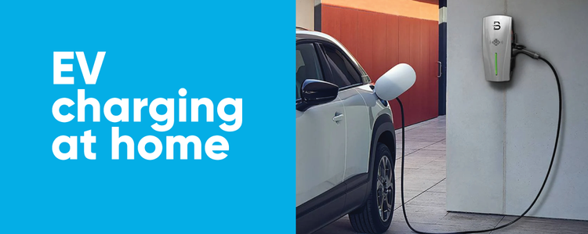

Webinar - January 15th, 12 Noon PT
Learn everything you need to know about charging your EV at home to maximize savings and convenience.
Charging at home is one of the major conveniences of owning an EV and the best way to reduce the costs of driving. The Department of Energy reports that 80% of EV charging happens at home. If you lease or own an electric vehicle and have off-street parking where you live, you’ll want to take advantage of all the benefits of home charging.
We’ll focus on home charging basics, including the differences between Level 1 and Level 2 chargers, how to save money on installation and charging practices, and what to consider so EV charging fits with other electrification measures you may be considering without triggering unnecessary expenses.
Register for our upcoming EV Charging webinar



Tour Tigard’s newest green apartments!
Tuesday, January 14th 5:30-7:00 PM
The Steward is the first certified Path to Net Zero property in Tigard, Oregon, offering fully electric living without the carbon operating footprint from fossil fuels. The Steward combines environmentally friendly living with purposeful design, where energy efficiency, sustainable practices, and sophisticated design coexist. The rooftop photovoltaic solar system (103 kW) generates energy to power building operations, fully electric apartments and EV charging. Come tour the building and see what the future could look like!
Tours of the building will be leaving from the lobby at 5:30 PM, 6:00 PM, and 6:30 PM. Following the tour you are welcome to enjoy light refreshments and connect with local environmental organizations Solar Oregon, Electrify Now, and Lake Oswego Sustainability Network in the community space on the 5th floor.
Register for The Steward Tour



Find resources to help you take action
Electrifying your home is the most powerful thing you can do to reduce your carbon emissions and accelerate the world to a clean energy future.
Our Take Action pages have helpful tips, contractor recommendations and other resources to help you electrify your home and transportation.
Electrify Oregon is a great resource for product information, incentive details and trusted contractors across the state.
If you have questions or comments, or need some advice about electrification in your home, please contact us at: brianstewart@electrifynow.net
Please share this newsletter with your friends and family.

Thanks and good luck with your electrification projects!



PO Box 10596, Portland, OR 97296, United States
Unsubscribe

